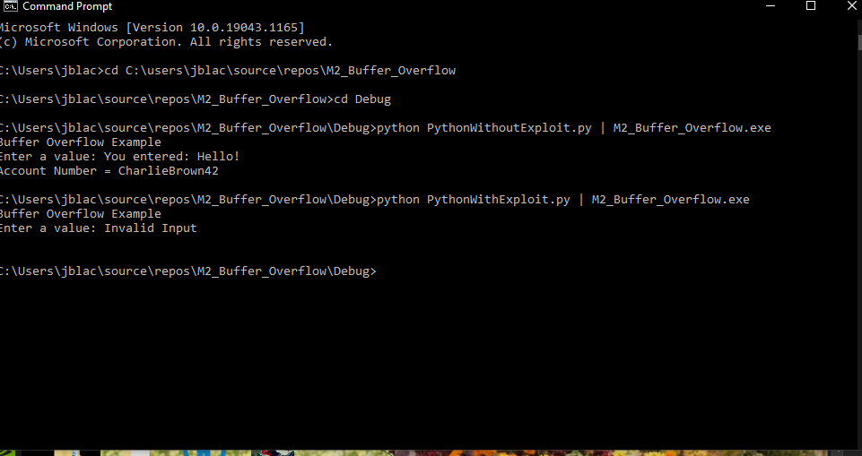

For the Buffer Overflow activity I chose to try and keep it simple. After the user provides the input, I wanted to read the length of the string and determine if it exceeded 20 characters. If it does, I just output the message “Invalid Input” and then I clear the user_input variable of values. Lastly, as confirmation that the array is now empty, I output the array to the console which shows as an empty line.